Title: | Replace function of NV Subsystem
References:
Distribution:
Author: | zuochen Wang | Date: 08.06.2012
Review:
Approved:
Remarks

Contents

1 Introduction 3
1.1 Scope 3
1.2 Acronym and definitions 3
1.3 General Description 3
1.4 Data Mapping 3
2 Add NV-Replace Supporting 3
2.1 Define Replace Object 3
2.2 Generate Code for These Subsystem. 4
2.2.2 Code Generate in the ES 5
2.3 Add Segment in XCL file 5
2.4 Add Project Specific Function in FEI 6
2.4.1 GetNvDataSRV 6
2.4.2 PutNvDataSRV 6
2.5 Functions In coordinator 7
2.5.1 StartupNVSubsystem 7
2.5.2 Start the FEI Communication with FEB 7

Introduction

Scope
This specification describes the replace function of 2 Wire Common Platform. the mechanism of the Data exchanging between FE and CB. Give an direction to implement the Replace function in your project.

Acronym and definitions
NV | Non-volatile Memory
FEB | Front End Board
EEPROM | Electrical Erasable PROM
UART | Universal Asynchronous Receive/Transmitter
CB | Communication Board
FEI

General Description
Most of ABB Measurement Product has the architecture of CB plus FEB. Some of data in FEB shall have an backup data in the CB and also some important data of CB shall have a backup data in FEB too. NV-Replace function of NV Subsystem is designed to give such support to meet the requiremtns.

Data Mapping

Protocol Package
FE
CB
Replace
Main(4k)
Backup(4k)
Replace
Replace
Seg Num
Data Replace

Add NV-Replace Supporting

Define Replace Object
Define a data class ReplaceStaticFrequentStaticDefault to define the object will be exchange between FEB and CB. Here is an example that defined in CurrentSubstem.

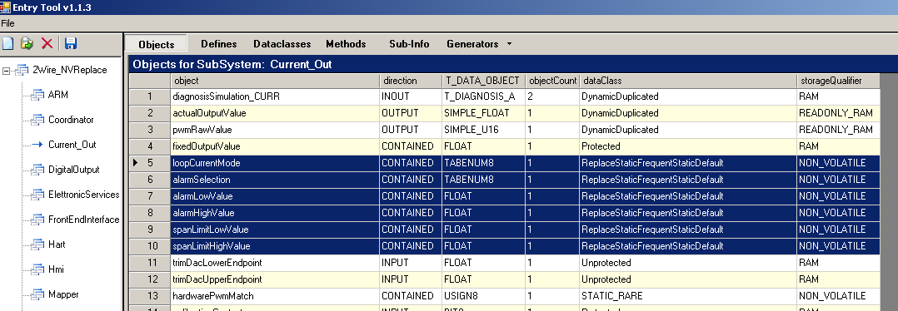

And also define some objects in ES.
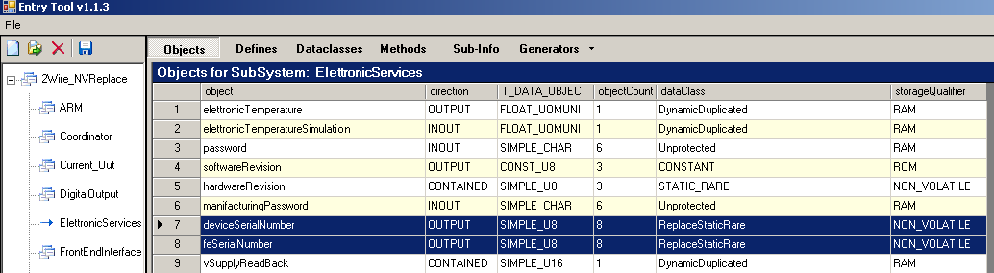

Generate Code for These Subsystem.

Data definitions in Current_Out _types.h

//! structure of ReplaceStaticFrequentStaticDefault block
typedef struct _T_CURRENT_OUT_REPLACE_STATIC_FREQUENT_STATIC_DEFAULT
{
//@SubGen start@ <DATACLASS ReplaceStaticFrequentStaticDefault>
TUSIGN8 loopCurrentMode;
TUSIGN8 alarmSelection;
TFLOAT alarmLowValue;
TFLOAT alarmHighValue;
TFLOAT spanLimitLowValue;
TFLOAT spanLimitHighValue;
//@SubGen end@ <DATACLASS ReplaceStaticFrequentStaticDefault>
} T_CURRENT_OUT_REPLACE_STATIC_FREQUENT_STATIC_DEFAULT;

Code generate in the file Current_Out_constructor.c

//! definition of ReplaceStaticFrequentStaticDefault data
#ifdef WIN32
#pragma bss_seg(".AAA$CURRENT_OUT_DATA")
const FAST T_CURRENT_OUT_REPLACE_STATIC_FREQUENT_STATIC_DEFAULT current_OutReplaceStaticFrequentStaticDefault;
const FAST T_CURRENT_OUT_REPLACE_STATIC_FREQUENT_STATIC_DEFAULT current_OutReplaceStaticFrequentStaticDefaultDefault;
#pragma bss_seg()
#else
#pragma dataseg=FAST CURRENT_OUT_REPLACE_STATIC_FREQUENT_STATIC_DEFAULT
const FAST __no_init T_CURRENT_OUT_REPLACE_STATIC_FREQUENT_STATIC_DEFAULT current_OutReplaceStaticFrequentStaticDefault;
#pragma dataseg=FAST CURRENT_OUT_REPLACE_STATIC_FREQUENT_STATIC_DEFAULT_DEFAULT
const FAST __no_init T_CURRENT_OUT_REPLACE_STATIC_FREQUENT_STATIC_DEFAULT current_OutReplaceStaticFrequentStaticDefaultDefault;
#pragma dataseg=default
#endif

Code Generate in the ES

Data definitions in ElettronicServices_types.h
//! structure of ReplaceStaticRare block
typedef struct _T_ELETTRONIC_SERVICES_REPLACE_STATIC_RARE
{
//@SubGen start@ <DATACLASS ReplaceStaticRare>
TUSIGN8 deviceSerialNumber[8];
TUSIGN8 feSerialNumber[8];
//@SubGen end@ <DATACLASS ReplaceStaticRare>
} T_ELETTRONIC_SERVICES_REPLACE_STATIC_RARE;

Segment allocation in ElettronicServices_constructor.c
//! definition of ReplaceStaticRare data
#ifdef WIN32
#pragma bss_seg(".AAA$ELETTRONIC_SERVICES_DATA")
const FAST T_ELETTRONIC_SERVICES_REPLACE_STATIC_RARE elettronicServicesReplaceStaticRare;
#pragma bss_seg()
#else
#pragma dataseg=FAST ELETTRONIC_SERVICES_REPLACE_STATIC_RARE
const FAST __no_init T_ELETTRONIC_SERVICES_REPLACE_STATIC_RARE elettronicServicesReplaceStaticRare;
#pragma dataseg=default
#endif

Add Segment in XCL file
// =============================================================================
// RAM PAGE FOR FILES
// =============================================================================

//1 - File CYCLIC_COMMON_REPLACE
-Z@(NEAR)BUFFER_CYCLIC_COMMON_REPLACE=_RAMPAGE_BEGIN-(_RAMPAGE_BEGIN+3*_SEGMENT_SIZE-1)
//------------------------------------------------------------------------------
// File CYCLIC_COMMON_REPLACE, start from Segment 0 to 2, totally 3 segments(0x32)
//------------------------------------------------------------------------------
-Z@(NEAR)HART_REPLACE_STATIC_FREQUENT_STATIC_DEFAULT=_RAMPAGE_BEGIN-(_RAMPAGE_BEGIN+3*_SEGMENT_SIZE-1)

//3 - File STATIC_COMMON_REPLACE
-Z@(NEAR)SEGMENTS_STATIC_COMMON_REPLACE=(_RAMPAGE_BEGIN+3*_SEGMENT_SIZE)-(_RAMPAGE_BEGIN+17*_SEGMENT_SIZE-1)
//------------------------------------------------------------------------------
// File STATIC_COMMON_REPLACE, start from Segment 3 to 22, totally 20 segments
//------------------------------------------------------------------------------
-Z@(NEAR)CURRENT_OUT_REPLACE_STATIC_FREQUENT_STATIC_DEFAULT=(_RAMPAGE_BEGIN+3*_SEGMENT_SIZE)-(_RAMPAGE_BEGIN+17*_SEGMENT_SIZE-1)

//2 - File CYCLIC_UNCOMMON_REPLACE
-Z@(NEAR)BUFFER_CYCLIC_UNCOMMON_REPLACE=(_RAMPAGE_BEGIN+17*_SEGMENT_SIZE)-(_RAMPAGE_BEGIN+1B*_SEGMENT_SIZE-1)
//------------------------------------------------------------------------------
// File CYCLIC_UNCOMMON_REPLACE, start from Segment 23 to 16, totally 4 segments
//------------------------------------------------------------------------------
-Z@(NEAR)HART_REPLACE_STATIC_FREQUENT_STATIC_DEFAULT_DEFAULT=(_RAMPAGE_BEGIN+17*_SEGMENT_SIZE)-(_RAMPAGE_BEGIN+1B*_SEGMENT_SIZE-1)
Z@(NEAR)ELETTRONIC_SERVICES_REPLACE_STATIC_RARE

//4 - File STATIC_UNCOMMON_REPLACE
-Z@(NEAR)SEGMENTS_STATIC_UNCOMMON_REPLACE=(_RAMPAGE_BEGIN+1B*_SEGMENT_SIZE)-(_RAMPAGE_BEGIN+1D*_SEGMENT_SIZE-1)
//------------------------------------------------------------------------------
// File STATIC_UNCOMMON_REPLACE, start from Segment 27 to 28, totally 2 segments
//------------------------------------------------------------------------------
-Z@(NEAR)HART_REPLACE_STATIC_FREQUENT_NO_DEFAULT=(_RAMPAGE_BEGIN+1B*_SEGMENT_SIZE)-(_RAMPAGE_BEGIN+1D*_SEGMENT_SIZE-1)

Add Project Specific Function in FEI

GetNvDataSRV
TUSIGN8 GetNvDataSRV_FE(TUSIGN16 sIdx, TUSIGN8* pData, TUSIGN8 length);
FEI shall add a sevice fucniton to get the speicified segment data from the FEB.
Parameter 1 TUSIGN16 sIdx: The replaced segment index.
Parameter 2 TUSIGN8* pData: Pointer to the replaced data buffer
Parameter 3 TUSIGN8 length: Data lenth to be transferred. Commonly it shall be 30.

PutNvDataSRV
TUSIGN8 PutNvDataSRV _FE(TUSIGN16 sIdx, TUSIGN8* pData, TUSIGN8 length);
FEI shall add a sevice fucniton to send the specified segment data to the FEB.
Parameter 1 TUSIGN16 sIdx: The replaced segment index.
Parameter 2 TUSIGN8* pData: Pointer to the replaced data buffer
Parameter 3 TUSIGN8 length: Data length to be transferred. Commonly it shall be 30.

Functions In coordinator

StartupNVSubsystem
Description: Calling this function to initialize the NV subsystem.

Start the FEI Communication with FEB
Description: As replace shall exchange data between FEB and CB .so the communication shall set up before the NV replace function execution.

InitializeNV_REPLACE
Description: Initializes the FE NV Common/Uncommon blocks, At the same time initializes the service page, Performs the Forced Replace or the Check and Repair if necessary.

Revision Chart

Rev. | Description of Version/Changes | Primary Author)s) | Date
0.1 |  | zuochen Wang | 2012-08-07

